Capstone Project Phase A

Parkinson's Perspective: Visualizing Impact

25-1-D-6

**Supervisor: Dr. Julia Sheidin**

**Supervisor: Dr. Avital Shulner**

**Omer Fatal – omer.omer92@gmail.com**

**Tanya Gendelman - TanyaGendelman@gmail.com**

**Table of Content:**

1. Introduction……………………………………………………………………………………..3
2. Related Work and Background……………………………………………………………….5
   1. Parkinson Disease in General………………………………………………………..5
   2. Impact of Parkinson's Disease Patients…………………………………………….5
   3. The Information Needs of People with Parkinson's Disease……………………..5
   4. The Importance of Explanations in Parkinson's Disease Management…………6
   5. Types of Textual Explanations……………………………………………………….6
   6. Types of Visual Explanations…………………………………………………………7
   7. Existing Solutions……………………………………………………………………...9
   8. Limitations of Current Parkinson's Disease Management Tools………………..17
3. Expected Achievements…………………………………………………………………...…18
4. Engineering Process……………………………………………………………...…………..19
   1. Process………………………………………………………………………………..19
      1. Pre-processing and Understanding the Visualized Data……….19
      2. Visualization Tools and Techniques………………………………20
      3. Initial Planning and Decision Making……………………………..21
      4. Prototype…………………………………………………………….22
   2. Product………………………………………………………………………………...23
   3. Expected Challenges………………………………………………………………...27
5. Evaluation / Verification Plan…...……………………………………………………………28
   1. Testing Plan…………………………………………………………………………..28
   2. Evaluation by User…………………………………………………………………...29

**Abstract**

Parkinson’s disease is a progressive neurological disorder that affects movement, balance, and coordination, making daily life challenging for patients. While there are tools that collect data and monitor symptoms, they are primarily designed with a clinical focus, leaving patients without actionable insights to understand how their daily activities affect their condition. This makes it difficult for patients to make informed decisions about their care.

Our project builds upon previous work that collected detailed data from Parkinson’s patients and focuses on transforming that data into clear and interactive visualizations. The system, accessible on both desktop and mobile devices, incorporates tools like heatmaps, bar charts, and line graphs, enabling users to track progress, analyze patterns, and identify relationships between daily activities and symptoms.

To enhance the user experience, the platform integrates both visual and textual explanations. Visual tools simplify complex data by highlighting trends and correlations in an intuitive format, while textual explanations provide straightforward, language-based clarifications. Together, these explanations bridge the gap between raw data and actionable insights, empowering patients to adjust their routines and make informed decisions.

By prioritizing a patient-centered design and intuitive tools, this project empowers Parkinson’s patients to better understand their condition and take a more active role in managing their health. The goal is to support patients in optimizing their daily routines and improving their overall quality of life.

**1. Introduction**

Parkinson's disease (PD) is a progressive neurological condition that deeply affects movement, balance, and coordination, leading to symptoms such as tremors, stiffness, and slowness of movement [1]. For those living with PD, managing the condition is a complex, ongoing challenge that requires careful tracking of symptoms and daily activities [2]. Small changes in routines, such as the timing of medications, the type or frequency of exercise, or even dietary choices, can significantly influence the progression of symptoms and overall well-being [1]. However, many patients find connecting their actions to their symptoms difficult, leaving them without the clarity they need to make informed decisions about their care [2].

While various tools have been developed to collect and monitor data on Parkinson's symptoms and routines, these tools often fall short of empowering patients directly [2]. Many present information in too complex or abstract ways, offering generalized reports or raw data that do little to illuminate the relationship between a patient's daily activities and their symptoms [2]. As a result, patients are frequently left to navigate their condition without clear guidance on optimizing their routines. Existing platforms also tend to focus more on aiding researchers or healthcare providers rather than directly benefiting patients [2]. For example, StrivePD help users better understand and manage Parkinson's disease [3]. PD-Insighter analyzing patient data but fails to provide actionable information that patients can easily use to improve their day-to-day lives [4].

In addition to these, dashboards—a common tool in healthcare for consolidating and visualizing complex data—are another promising but underutilized solution in the management of PD [5]. Dashboards aggregate and present data from multiple sources, such as wearable devices, smartphone applications, and electronic health records, in a visual format that facilitates comprehension and decision-making [5]. They enable real-time monitoring, analysis, and the identification of trends, which can be particularly useful for chronic diseases like Parkinson's, where symptoms fluctuate considerably over time and even throughout the day [22]. Despite their potential, dashboards often fall short due to a lack of adaptation to the unique needs of patients managing PD. For example, while these tools can consolidate data such as medication timing, movement patterns, and self-reported symptoms, their design frequently prioritizes data collection over actionable insights [22]. This misalignment means that many existing dashboards focus on assisting healthcare providers in diagnosing and monitoring patients rather than helping patients themselves understand or manage their symptoms [5]. Moreover, the design of these dashboards often fails to account for the variability and complexity of PD symptoms [citation]. Patients and clinicians may struggle to translate the data into meaningful actions without tailored visualizations or intuitive feedback mechanisms [5]. The relevant information that has to be presented includes symptom trends, medication schedules, physical activity patterns, sleep quality, and dietary impacts. This data can be displayed using various methods, such as interactive charts, timelines, or personalized dashboards tailored to the patient’s needs. To evaluate the best way to present the data, sessions can be held with Parkinson’s patients to gather feedback on different formats. These discussions will provide insights into how patients interpret the data and identify the most accessible and effective ways to display it [5]. This disconnect creates a significant gap in care, leaving many Parkinson's patients feeling disempowered [2]. They often struggle to see how specific actions—such as exercise, medication timing, or dietary adjustments—might improve their symptoms or overall quality of life [1]. Our solution seeks to close this gap by using technology to transform data into clear, actionable insights. By focusing on advanced but accessible visualization tools, we aim to help patients understand the connections between their daily activities and their symptoms in a meaningful and personalized way.

Our project based on the work that was done in the previous semester, which aimed to collect data from Parkinson’s patients. The collected data includes information about daily activities, medication adherence, sleep quality, and various symptoms.

The goal of our proposed approach is to transform those data into intuitive visuals, helping patients understand how their choices impact their condition.

For example, interactive charts and graphs can illustrate symptom trends, helping patients recognize patterns such as reduced tremors after exercise or improved sleep quality with specific dietary habits. Instead of simply collecting data for research or clinical adjustments, our approach emphasizes empowering patients directly, giving them the tools they need to take control of their care. Through tailored feedback, patients will be able to identify what works best for them, adjust their routines, and make more informed decisions that improve their quality of life.

This approach primarily empowers Parkinson's patients by providing them with clear, actionable insights into their condition, enabling them to better understand how their daily choices affect their symptoms and overall well-being. By focusing on patient-centered visualization tools, our solution aims to enhance self-management and decision-making, helping individuals take control of their care in a meaningful way. While the primary goal is to benefit patients directly, caregivers and healthcare professionals may also gain valuable insights from the visualized data, fostering better collaboration and communication when needed. Ultimately, our vision is to transform the management of Parkinson's disease by presenting complex data in a clear and accessible way. By focusing on intuitive and personalized visualizations, we aim to help patients better understand their condition and actively engage in their care journey. Through this project, we explore how technology and visualization can redefine living with Parkinson’s disease, offering tools that primarily benefit patients while also supporting their broader care network.

**2.Background and Related Work**

**2.1 Parkinson disease in general**

Parkinson's disease (PD) is a long-term condition where certain brain cells, especially in the substantia nigra, are lost over time [6]. This causes less dopamine to be produced, which is essential for movement and other functions [1]. The exact cause of PD is not fully known, but it likely involves a mix of genetic risks and environmental factors [6]. Most cases occur after the age of 60, though early-onset cases can happen [2]. PD is the second most common neurodegenerative disease worldwide and is expected to increase due to aging populations [2]. Early diagnosis and improved treatments are critical to managing the disease effectively [4] .

**2.2 Impact on Parkinson's Disease Patients**

PD deeply affects the lives of patients, both physically and emotionally. Symptoms like tremors, stiff muscles, and slow movements make it hard to do everyday tasks such as walking, dressing, or eating [1]. These difficulties can cause patients to lose their independence and rely more on caregivers [2]. In addition to movement problems, non-motor symptoms like depression, anxiety, trouble sleeping, and memory issues also make life harder, lowering patients' overall quality of life [6]. Social isolation is another common problem for people with PD. Visible symptoms, like shaking or freezing while walking, can make them feel embarrassed or uncomfortable in social settings, leading them to avoid others [4]. The disease’s gradual worsening adds emotional challenges, as patients face uncertainty about their health and increased dependence on others [5].

**2.3 The Information Needs of People with Parkinson's Disease**

People with PD often struggle to get the information they need to manage their condition effectively. Many patients lack clear insights into how their daily activities, diet, and medications affect their symptoms and overall health [1][6]. For example, they may not know which types of exercise are most helpful, how specific foods impact their energy or movement, or how to adjust their medication schedule to improve symptom control [1][7]. Patients also face challenges in understanding how their condition progresses over time and how different factors, like stress or sleep, contribute to changes in their symptoms [6]. This makes it harder for them to make decisions about their care. While general advice is available, it is often not personalized to their unique situation, leaving gaps in their understanding of how to live well with Parkinson's [2][4]. Online communities provide some support by allowing patients to share experiences and tips, but these discussions often lack scientific backing or specific guidance tailored to individual needs. This shows a clear need for more personalized, evidence-based information to help patients make better decisions about their health [3].

**2.4 The Importance of Explanations in Parkinson's Disease Management**

Explanations, whether textual or visual, play a pivotal role in helping patients with Parkinson's disease understand and manage their condition. Textual explanations use clear, accessible language to describe symptoms, recommendations, or data insights, making them relatable and easy to follow. For example, a simple reminder about medication adherence can help patients connect their actions to symptom control, which is crucial for managing symptoms over time [6]. Research highlights that effective communication, particularly using clear and personalized explanations, can reduce patients' anxiety and increase their confidence in managing their condition, thereby promoting better health outcomes [6]. Visual explanations, on the other hand, transform complex data into intuitive formats like charts, graphs, or heatmaps, enabling patients to track trends and correlations over time. Studies have shown that visual tools can facilitate self-management by helping patients recognize patterns in symptoms and lifestyle factors, which supports more informed decision-making [8]. These tools are especially beneficial in empowering patients to make connections between their daily routines and symptom fluctuations, thereby enhancing their ability to adapt their behaviors accordingly [8]. Moreover, educational programs that incorporate both textual and visual elements have been found to improve patients' understanding of their condition and foster a more proactive approach to disease management [9]. These programs provide patients with actionable insights and strategies that they can apply in their daily lives, leading to increased life satisfaction and better disease outcomes [9]. Both types of explanations serve as bridges between raw data and meaningful insights, empowering patients to make informed decisions and enhancing communication with healthcare providers. By combining these approaches, data visualization tools can cater to diverse needs, ensuring that information is both comprehensible and actionable for managing Parkinson's effectively.

**2.5 Types of Textual Explanations**

Textual explanations are detailed, language-based clarifications that transform complex medical data into accessible insights for patients. These explanations bridge the gap between technical details and actionable knowledge, empowering patients to understand their health conditions and the reasoning behind treatment decisions. It is important that these explanations simplify complex data to make it more relatable for users, as this clarity helps them engage more confidently with medical systems and better understand the presented information [10]. Textual explanations also play an important role in supporting patient-centered care by presenting recommendations in a way that relates to each individual's specific health situation. This personalization helps patients better understand their options and feel more involved in decision-making [13].

In the context of chronic conditions like Parkinson’s disease, Natural Language Explanations simplify medical jargon into conversational terms. For example, a system might explain: "Your medication adherence this week was 70%. Missing doses can increase symptoms like tremors and stiffness. Consider setting a daily reminder." Such explanations enhance patient comprehension by avoiding overly technical language. [13], however they may sometimes lack the precision necessary for data-intensive decision-making contexts, where detailed and specific information is crucial[14].  
Rule-Based Explanations, on the other hand, use structured logic to deliver clear guidance. For instance: "Your average step count this week was below 5,000 steps per day, which is less than the recommended level for managing symptoms." These explanations are valued for their "ability to provide transparency by mapping decisions to predefined rules and guidelines" [12], but may feel rigid to some users [11].

Statistical Explanations deliver data-backed insights, such as: "There is an 85% probability that your medication regimen needs adjustment. Please consult your doctor." While such explanations "offer a high degree of precision by quantifying outcomes and probabilities," they "require careful contextualization to ensure lay users can interpret them correctly" [10][13].Tailored textual explanations have been shown to improve patient engagement, comprehension, and adherence to medical recommendations, contributing to better health outcomes. One study concludes that, "explanations that align with user expertise and health context significantly enhance the effectiveness of clinical decision support systems" [14].

**2.6 Types of Visual Explanations**

Visual explanations are designed to help users better understand complex information by presenting it in a clear and intuitive visual format. These explanations reduce cognitive load by making abstract concepts more tangible through images, diagrams, and visual comparisons. In healthcare, visual-based interventions, such as images, videos, and pictorial aids, have proven effective in enhancing comprehension and improving health literacy among clinical populations [17]. For example, visual aids can help patients better understand medical diagnoses and treatment options by simplifying complex data into more digestible formats [17]. Visual explanations can be divided into several types based on their purpose and presentation method.

Image-based grounding focuses on highlighting specific regions in an image to explain decisions made by machine learning models. For example, in [16], bounding boxes are used to highlight features such as a red beak or a black face patch on a cardinal bird. In healthcare, image-based explanations are frequently used to make diagnostic processes more accessible to patients [17]. In the context of Parkinson’s disease, image-based grounding can be applied to MRI scans or interactive brain diagrams to highlight the substantia nigra, a brain region significantly affected by the disease. Highlighting this area helps patients understand how the loss of dopamine-producing neurons leads to symptoms such as tremors and rigidity [15]. Additionally, image-based explanations can be applied to skin images to detect early signs of Parkinson’s-related skin disorders, such as seborrheic dermatitis, by marking areas of increased risk [15].

Counterfactual explanations provide a visual comparison between a specific classification and an alternative possibility. For example, in gait analysis, a counterfactual explanation could demonstrate that if the patient’s walking speed and stride length were within the normal range, they would not be flagged as having Parkinson’s [17]. Similarly, comparing a healthy brain to a Parkinson’s-affected brain can illustrate the role of the substantia nigra in the diagnosis. Counterfactual explanations are particularly useful for patients to understand what-if scenarios, as they show how small changes in medical parameters could lead to different diagnoses [15]. In voice analysis, a counterfactual explanation could show that if the patient’s pitch variation were higher, the likelihood of Parkinson’s would decrease [17]. Educational visual aids help simply complex concepts for patients by improving their health literacy and overall comprehension [17], emphasize the importance of using diagrams and illustrations to show affected brain regions , as well as line graphs to track symptom fluctuations over time [15]. Flowcharts explain cause-and-effect relationships, such as the connection between dopamine loss and motor dysfunction. Additionally, comparative bar charts can highlight differences between motor and non-motor symptoms, such as cognitive decline, which significantly affects patient's quality of life [15].

By combining image-based grounding, counterfactual explanations, and educational visual aids, it is possible to enhance patient understanding, build trust in the decision-making process, and reduce cognitive load when processing complex information [17].

**2.7 Existing Solutions**

**SENSE-PARK App**

The SENSE-PARK App provides a powerful example of a visual explanation through its timeline visualization feature. This graph displays akinesia scores over time, clearly highlighting changes in movement levels. The visual representation integrates patient activities, such as "walking" or "akinesia right," directly into the timeline as labeled markers. Akinesia right and akinesia left refer to the loss or reduction of movement on the right or left side of the body, respectively. This approach allows patients and clinicians to intuitively understand the impact of daily activities on akinesia levels, offering a powerful and effective tool for managing and analyzing Parkinson’s disease data.[18]

Figure 1. Shows akinesia scores over time, linked to patient-marked activities.

**Existing Visualization Methods for Parkinson’s Data**

The visualization methods presented in Figures 2, 3, and 4 highlight diverse approaches to explaining and analyzing data for Parkinson’s patients. Figure 2 provides a bar graph showcasing the most common Diagnosis-Related Groups (DRGs) among Parkinson’s patients, visually explaining the primary medical conditions leading to hospitalizations. Figure 3 uses a box plot to illustrate the average hospitalization costs for the most frequent procedures, offering a clear comparison of financial burdens associated with various treatments. Figure 4 combines three key hospitalization metrics—average daily cost, average length of stay, and procedure frequency—into a multi-metric bar graph, enabling an integrated view of resource-intensive procedures. Each of these figures serves as a visual explanation, presenting complex data in an intuitive format that aids in understanding patient conditions, treatment patterns, and their economic implications. Together, these visualizations demonstrate the power of data-driven insights to improve decision-making in Parkinson’s disease care.[19]

Figure 2. The percentage of PD patients in top 6 disease related groups (DRGs).

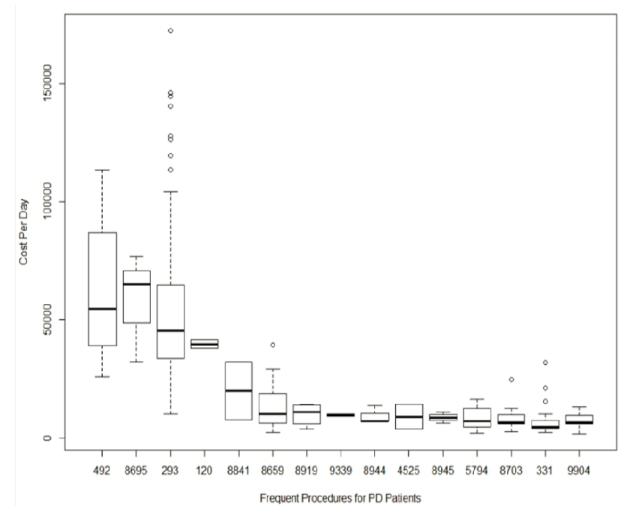

Figure 3. The average hospitalization cost for top 15 frequent procedures.

Figure 4. The comparison of average hospitalization cost, average hospital stays and frequent procedures.

**DataPark**

The DataPark Report is a powerful tool that uses visual explanations to present key health metrics for Parkinson’s patients. It integrates three main types of visualizations:

The energy expenditure chart, shown as a line or area graph, tracks the calories expended by the patient over time, offering a clear view of daily activity levels. The physical activity chart, displayed as a bar graph, stacked bar chart, or heatmap, segments activity by time periods (e.g., morning, afternoon) to highlight symptom fluctuations and medication responses. The sleep analysis graph, represented as a timeline or bar chart, visualizes sleep patterns, including durations, wake-ups, and position changes, providing crucial insights into sleep quality [20].

Figure 5. An example template of a DataPark report, containing energy, charts, a physical activity chart and measures

**Dashboards as a Tool for Visualizing Parkinson's Data**

The dashboard presented in the article uses visual explanations to convey complex data about Parkinson's patients in an accessible and intuitive format. It includes several types of graphs that help clinicians understand real-time patient-reported outcomes and sensor data. The medication intake section uses a timeline graph to display when medications were taken throughout the day. This visual explanation enables clinicians to quickly assess adherence to medication schedules and timing. The Digital ON/OFF Diary (ePRO) employs a line graph to show fluctuations in ON/OFF states, activity intensity, dyskinesia, and their correlation with medication timing, providing a clear and intuitive representation of symptom variations over time. Additionally, the symptom severity ratings section uses bar graphs to visualize changes in symptom severity, such as tremor, rigidity, and bradykinesia, both on a daily and hourly basis. These visual explanations provide a graphical summary of symptom changes, transforming complex health data into actionable insights. Such visualizations are not only efficient but also crucial for improving the decision-making process, as they allow clinicians to quickly identify patterns and correlations that might be difficult to discern in raw data [21].

Figure 6. Clinician dashboard of displays for an individual PD patient. The clinician dashboard displays medication intake by drug name, a digital ON/OFF diary (ePRO), and daily/hourly symptom severity ratings (ePRO) for a given date range.

**StrivePD**

StrivePD uses advanced data visualization tools to provide users with clear, actionable insights into their condition, empowering both patients and healthcare providers to track progress and make informed decisions. The Symptom Log (Fig 7) feature utilizes color-coded indicators—red for severe, yellow for moderate, green for mild, and blue for absence of symptoms—to visualize key symptoms such as balance issues, freezing, rigidity, tremor, and dystonia. This allows users to quickly assess symptom trends and compare the frequency and intensity of symptoms between recent and previous periods, helping to identify patterns and areas of concern. The Activity Dashboard (Fig 8,9) provides a breakdown of how time is spent across various physical activities, such as walking, cycling, and swimming, using stacked bar charts where each activity is represented by a distinct color. This dashboard compares total activity time and logs across periods, enabling users to track their adherence to exercise goals and understand the impact of physical activity on their symptoms. The Tremor Analysis Dashboard (Fig 10) offers a detailed view of tremor activity throughout a 24-hour period using bar graphs divided into 10-minute intervals, which compare recent and previous periods. It also includes summary metrics, such as average daily tremor duration and percentage reductions, providing a clear picture of how lifestyle changes or treatments influence symptom severity. Together, these visualizations, enhanced by AI-generated summaries and intuitive design, transform raw health data into meaningful insights that foster patient engagement, support proactive symptom management, and improve communication with healthcare providers for tailored and effective care.[3]

Fig 7: Data recorded from symptom logs, daily check-ins and notes.

Figure 8: Total time distributed in activities logged during the recent period.

Figure 9: Data recorded by apple health and activity logs.

Figure 10: Tremor duration in 10-minute intervals over 24 hours for easy symptom tracking.

**PD – Insighter**

PD-Insighter is an advanced visual analytics system designed to assist clinicians in monitoring and treating patients with Parkinson's disease (PD) by leveraging video and sensor data to analyze motor functions in real-world environments [4]. The system’s innovative approach centers around intuitive data visualization tools that provide actionable insights into patient behavior and movement patterns. At its core, the system features an Action Summary and Timeline Chart, which combines a bar graph summarizing the total time spent on activities like sitting, walking, or standing, with a stacked timeline that visually represents the sequence of these activities throughout the day [4]. This enables clinicians to identify high-level behavioral trends as well as detailed temporal patterns.

Additionally, PD-Insighter employs Temporal Heatmaps to highlight body variables associated with specific activities, such as identifying potential freezes during walking [4]. These heatmaps use color gradients to encode the intensity or frequency of movement, helping clinicians quickly pinpoint anomalies or critical patterns. For example, freezes are visually represented by sudden shifts in movement color patterns, allowing for easier identification of motor abnormalities [4].

To facilitate deeper exploration, PD-Insighter includes an Event Data Chart with Interactive Range Sliders, allowing users to zoom in on specific timeframes and events. The global slider provides a broad overview of activity data, while the local slider supports detailed examination of critical moments, such as analyzing motor patterns before or after a freezing episode [4]. By combining these visualization tools with advanced data aggregation and filtering techniques, PD-Insighter reduces noise and emphasizes clinically significant outliers, enabling clinicians to seamlessly transition between high-level summaries and detailed investigations [4]. The system’s design was developed collaboratively with healthcare professionals, ensuring that the tool aligns with the needs of clinicians and patients [4].

Figure 11. PD Insighter Dashboard Visualizations

**2.8 Limitations of Current Parkinson's Disease Management Tools**

Despite the potential of existing visualizations in Parkinson’s disease management tools, significant limitations remain in their design and accessibility for both patients and clinicians. Tools like StrivePD and PD-Insighter rely on various visual explanations but often fail to balance clarity, usability, and actionable insights [4]. For instance, StrivePD integrates activity tracking and symptom visualization using bar graphs, line charts, and heatmaps to illustrate trends like tremor severity or physical activity fluctuations over time. However, the data presentation often lacks contextual integration, leaving users to interpret patterns without clear guidance on how to act upon them [3][21].

Similarly, PD-Insighter employs temporal heatmaps and stacked body-variable charts to visualize movements, medication timing, and potential freezing episodes, but these designs are primarily aimed at clinicians, making them less intuitive for patient use [4]. Additionally, while tools like the SENSE-PARK App effectively visualize akinesia levels through timeline graphs, they may oversimplify complex symptom interactions by isolating specific activities without addressing broader contextual factors [18]. Other visualizations, such as those in the DataPark Report, offer multi-layered insights through stacked bar graphs and heatmaps to explain energy expenditure, physical activity, and sleep patterns [20]. Although these methods provide valuable overviews, they risk overwhelming users with excessive data if not tailored to individual needs [3].

While offering a consolidated view of real-time sensor data and patient-reported outcomes, clinical dashboards often prioritize data presentation over actionable feedback [21]. As a result, patients and clinicians must make independent inferences about correlations between medication intake and symptom fluctuations [4]. To truly empower users, future visualization approaches must integrate tailored feedback, focus on simplifying complex patterns, and ensure that designs are equally accessible to both patients and healthcare providers [18][20].

These adjustments are crucial for transforming raw data into intuitive and actionable insights that improve decision-making and patient engagement [3][21].

**3. Excepted Achievements**

The primary objective of this project is to develop a web-based dashboard that enables Parkinson's disease (PD) patients to visualize and better understand their daily activities and how these activities impact their symptoms over time. The system will transform raw health data (such as medication adherence, sleep patterns, physical activities, and symptom reports) into clear and interactive visualizations that patients can easily interpret. The final product will be a user-friendly platform accessible from both mobile devices and desktop computers.

The success criterion for our project will be

1. The system accurately transforms raw data into meaningful visualizations.
2. The system should encourage patients to engage with their data regularly, providing them with tools to explore their routines and identify areas for improvement.
3. The dashboard is accessible on both desktop and mobile devices.
4. The interface is intuitive and easy to use.

**4.Engineering Process**

**4.1 Process**

Our engineering process began with an analysis of existing resources. We provided a literature review and explored various data visualization tools and techniques to identify the most effective methods for presenting the collected data in an intuitive and accessible format.

**4.1.1 Pre-processing and Understanding the Visualized Data**

The process began by reviewing the Excel file where Michael documented his daily activities over several months. This file contained detailed records of his routines, including sleeping patterns, physical activities (such as sports), food intake, and medication schedules. We divided these activities into categories to understand the data better and identify patterns and trends.

The categories we defined include:

* Physical Activity (e.g., walking, sports).
* Nutrition (e.g., meals, dietary choices).
* Rest and Sleep Patterns (e.g., hours of sleep).
* Medication Adherence (Times and types of medications taken).
* Symptoms: Descriptions of how the patient felt (pain, stiffness, tremors, and other symptoms).
* General Feeling and the Parkinson's Condition Scores.

This categorization was crucial for creating relevant visualizations that reflect different aspects of daily life and help Michael, as well as other patients, comprehend their routines better.

**4.1.2 Visualization Tools and Techniques**  
An important part of the process involved exploring various visualization tools and frameworks that could be used to present the collected data effectively, such as Python Dash, Tableau and D3.js . After thoroughly evaluating these tools, we selected Tableau for its ability to create interactive dashboards and dynamic graphs that can be updated in real-time, offering a user-friendly and engaging visualization experience.

In addition to these tools, we comprehensively reviewed existing dashboard solutions in healthcare applications, such as StrivePD, PD-Insighter, and the SENSE-PARK App. These dashboards demonstrated effective methods for consolidating and presenting complex data in visual formats that facilitate comprehension and decision-making. For example:

* StrivePD: Uses interactive charts and color-coded indicators to visualize symptom severity and physical activity trends, making it easier for users to identify patterns.
* PD-Insighter: Focuses on sensor data and real-world activity tracking, offering detailed analyses of motor functions through heatmaps and interactive timelines.
* SENSE-PARK App: Combines timeline visualizations with event markers, enabling patients to understand the effects of daily activities on their symptoms intuitively.

By studying these solutions, we identified the best practices and gaps, such as needing for more patient-centered visualizations and actionable insights. These findings informed our decision to develop an accessible web-based system with features tailored to Parkinson’s patients, emphasizing clarity, engagement, and ease of navigation.

We identified the following visualization types as particularly relevant for our project:

* Time-Series Graphs: To show trends over time (e.g., daily sleep hours).
* Bar Charts: These are used to compare different types of activities.
* Heatmaps: To illustrate the frequency and intensity of activities throughout the day.
* Dashboards: To provide a consolidated view of multiple metrics, allowing patients to easily navigate between different types of visualizations and track their progress over time.

The use of dashboards is especially important in our project, as they provide a comprehensive, interactive interface that can display various aspects of Michael's data in one place. Dashboards can integrate different visualization types, making it easier for users to understand correlations between activities and their impact on symptoms.

**4.1.3** **Initial Planning and Decision Making**

A critical part of our process was reviewing the interviews conducted by the previous team with Michael. These interviews provided valuable insights into his daily struggles, needs, and expectations from a data visualization tool. His persona, developed by the previous team, helped us understand the real-world challenges faced by Parkinson's patients and guided our design decisions.

Key insights from the interviews include:

* Patients need visual tools that are simple yet detailed enough to highlight patterns in their daily activities.
* The tool should focus on presenting collected data.
* Visual representations must be clear and engaging to maintain patient interest.

Our approach focuses on visualizing collected data to empower patients to recognize patterns in their daily. By transforming raw health data into intuitive visual formats, we aim to make complex information more accessible to patients.

We will choose a user-centered design because:

* Patients often struggle to track how their daily activities correlate with their symptoms.
* Clear visual feedback can improve patient engagement with their data.
* Visualizations reduce cognitive load and make it easier for patients to explore trends independently.

**The Architecture of the System:**

* Frontend: We chose React for its ability to create a responsive, user-friendly interface for both desktop and mobile.
* Backend: We chose Node.js for its efficiency in handling logic, user requests, and database communication.
* Database: We chose MongoDB for its scalability and ability to store user data efficiently.
* Visualization: We chose Tableau to deliver dynamic, interactive dashboards that provide actionable insights.

**4.1.4 Prototype**

As part of the user-centered design process, we created a prototype of the application's user interface using Figma, a web-based design tool. Figma allowed us to ensure the design met the needs of our PD patient. We focused on creating an intuitive, user-friendly interface that simplifies data entry and retrieval for essential daily activities. The prototype allowed us to prepare effectively for our meeting with the client and enhanced our ability to communicate clearly and fully understand his needs and desires.

Summarize of the meeting with Michael:

The meeting with Michael, a Parkinson's disease patient, was held at Braude College in Karmiel. Attendees included our project team, supervisors Julia and Avital, Michael, and Oranit, a representative of "The Flag Project" at the college, who helped establish the connection between Michael and our team. The purpose of the meeting was to present different types of visualizations and gather feedback on their usability and effectiveness for tracking Michael's daily activities, symptoms, and overall well-being.

We show three types of visualizations to Michael, each focusing on different aspects of his data:

1. **Heatmap: Monthly Analysis** – This visualization provided a monthly overview of Michael’s average feeling scores, highlighting patterns across weeks and days. The interactive design allowed him to navigate to specific days for detailed insights, including an analysis of activities contributing to his well-being.
2. **Line Chart: Daily Analysis** – This graph demonstrated the correlation between Michael’s activities and their impact on his feeling scores throughout the day. Activities such as sleep, nutrition, physical activity, and medication adherence were color-coded, allowing Michael to identify which actions positively or negatively influenced his well-being over time.
3. **Bar Chart: Daily Activity Distribution** – This chart detailed the breakdown of Michael’s activities (e.g., food consumption, medications, sleep/rest, and physical activity) across different times of the day. It emphasized the quantity of each activity and its alignment with his overall well-being.

Michael provided valuable feedback during the session. He appreciated the simplicity and clarity of the visualizations, particularly the heatmap’s ability to present a comprehensive overview and the interactive elements that allowed him to explore specific days.

In addition we learned from Michael that textual explanations are less important to him, as he prefers explanations to be conveyed in a visual format. This insight further solidified our focus on creating intuitive and interactive visualizations rather than relying heavily on written explanations.

**4.2 Product**

The project will be developed as a web-based system that can be accessed from both mobile phones and desktop computers. The system will be designed to be fully responsive, ensuring a seamless and user-friendly experience across different devices and screen sizes. The web application will allow users to easily view and interact with their data, regardless of the platform they use to access it.

**Screens of the application:**

Monthly Analysis: This screen contains the "Monthly Feeling and Parkinson Score Overview".

The Monthly Analysis screen provides a comprehensive overview of two key metrics for Parkinson’s disease management: the Feeling Score (top-right corner of each square) and the Parkinson Condition Score (bottom-left corner of each square). Structured as a calendar-like heatmap, the rows represent weeks, and the columns represent days of the week. Each square is divided diagonally, with the Feeling Score reflecting how the user feels (ranging from 1 to 5) and the Parkinson Condition Score indicating symptom severity (also ranging from 1 to 5). The heatmap uses a color-coding system for quick interpretation: green represents positive scores (e.g., 4-5 for Parkinson Condition Score, 4-5 for Feeling Score), yellow indicates moderate scores, and red highlights challenging scores (e.g., 1-2 for Parkinson Condition Score, 1-2 for Feeling Score).

This visualization allows users to track and compare their well-being and Parkinson condition over an entire month, identifying patterns such as days with high symptom severity but positive feelings or consistently low scores that may require intervention. Additionally, each square is interactive, allowing users to navigate to the Dashboard screen for detailed breakdowns of activities and their impacts.

Integrating of two key metrics into one visualization empowers users to make informed adjustments to their routines and better understand the relationship between their daily activities, symptoms, and overall well-being.

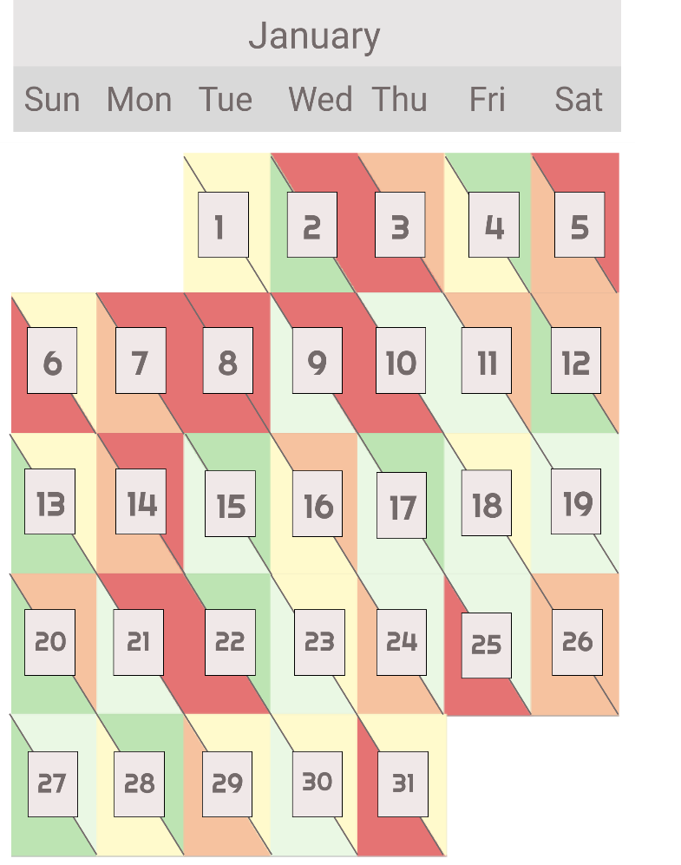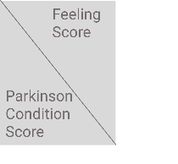

Dashboard Screen: This screen provides detailed visualizations and textual explanations for the chosen day.

After selecting a specific day from the Monthly Analysis heatmap, users are directed to the Dashboard screen. This screen is designed to help users gain deeper insights into their daily activities, their well-being, and symptom severity.

The dashboard features the Daily Analysis Graph as the primary visualization, offering an overview of activities mapped alongside their corresponding Feeling Scores and Parkinson’s Condition Scores throughout the day. This graph enables users to track changes in well-being and symptoms, highlighting how various activities, such as sleep, nutrition, exercise, and medication, influence their scores.

In addition, when users click on a medication logo within the Daily Analysis Graph, a short textual explanation appears. This pop-up provides detailed information about the specific medication taken, including its name and dosage.

Below the Daily Analysis Graph, two additional visualizations offer more specific insights into the user’s daily habits:

1. **Food Precursors by Category**: A bar chart that breaks down the number of servings consumed from different food categories, such as fruits, vegetables, proteins, and carbohydrates. This visualization helps users evaluate the balance of their diet and identify any nutritional gaps.
2. **Daily Sleep and Exercise Hours**: A bar chart that summarizes the total hours spent on sleep and exercise, providing a clear view of the balance between rest and physical activity.

This multi-faceted dashboard integrates interactive visualizations with actionable textual insights, empowering users to better understand their daily routines, identify patterns, and make informed adjustments to improve their health and manage Parkinson’s disease effectively.

Daily Analysis:

The Daily Analysis is a graph that maps activities alongside their corresponding Feeling Scores and Parkinson's Condition Scores throughout the day, helping users track fluctuations in well-being and symptom severity. The Y-axis represents the score range (1 to 5), where 1 indicates the worst feeling or most severe symptoms, and 5 indicates the best feeling or least severe symptoms. The X-axis displays the time of day. The graph includes two lines: a blue line for the Feeling Score, representing changes in general well-being, and a red dashed line for the Parkinson Condition Score, tracking symptom severity. Each activity is marked by a color-coded circle: yellow for sleep patterns, green for nutrition, blue for physical activity, and red for medication. At the top of the screen, the daily average Feeling Score and daily average Parkinson's Condition Score are displayed for a quick summary.

This visualization enables users to correlate their activities with well-being and symptom trends, providing actionable insights to help them identify patterns and optimize their daily routines.

Food Precursors Chart:

This bar chart summarizes the servings consumed from various food categories throughout the day. The X-axis lists categories like fruits, vegetables, carbohydrates, proteins, dairy, sugars, and beverages, while the Y-axis represents the number of servings. For example, vegetables may be the most consumed category, followed by carbohydrates and proteins, with other categories like fruits and dairy having fewer servings. This visualization helps users evaluate their dietary balance, identify nutritional gaps, and make healthier choices.

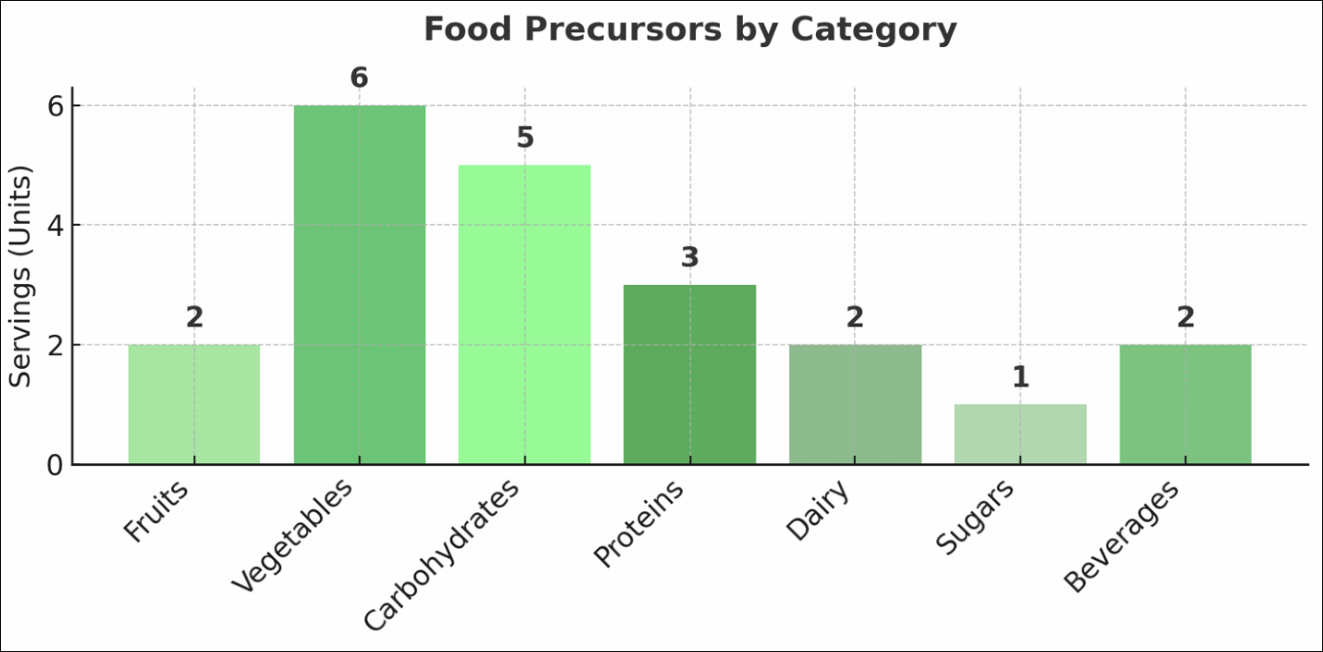

Daily Sleep and Exercise Hours Chart:

This bar chart shows the daily distribution of hours spent on sleep and exercise. The yellow bar represents total sleep hours, and the blue bar represents exercise hours. The X-axis shows a 24-hour timeline, while the Y-axis categorizes the activities. This visualization allows users to assess how well they balance rest and physical activity, providing insights to optimize their routines for better health and well-being.

**4.3 Expected Challenges**

As a continuation project, one of the primary challenges we anticipate is establishing a connection to the data collected in the previous phase. Ensuring seamless integration of data into our system is crucial for creating meaningful visualizations. To address this, we have identified three potential approaches:

* + - 1. Integration with an Existing System: If we are part of the existing system developed by the previous team, we will establish a direct connection. In this scenario, clicking the "Show Visualization" button in the previous application's interface will seamlessly redirect users to our system, where the visualizations will be displayed.
      2. Developing an Independent System: If we operate as a standalone system, we will create our own database to store and manage the data. This will involve designing a page that allows users to upload their data, which will then be processed and visualized, starting with the heatmap screen.
      3. Using the Excel File from Michael: Another possibility is leveraging the Excel file containing the data Michael recorded about his daily activities. Although this file is incomplete and not entirely structured, it can serve as a starting point for developing visualizations. Preprocessing steps will be required to clean, organize, and interpret this data before importing it into the system.

**5. Evaluation / Verification Plan**

To ensure the system operates correctly and meets its intended purpose, we will evaluate it using the following steps:

* Execute the Testing Plan: Conduct comprehensive tests to identify potential issues, validate functionality, and ensure that all components work seamlessly together.
* User Evaluations: Have the system tested by real users, specifically our client, Michael, to gather feedback on its usability, clarity, and overall effectiveness.

This testing plan outlines the strategy for evaluating the visualization dashboard. The primary goal of this plan is to ensure that the system meets its functional and performance requirements, providing Parkinson’s patients with an intuitive and effective tool for understanding their daily activities and symptoms.

To ensure the reliability and effectiveness of our final product, we have outlined a comprehensive testing plan detailed in the table below. This plan helps identify potential challenges, weaknesses, and areas that require accuracy verification.

**5.1 Testing Plan**

|  |  |  |  |
| --- | --- | --- | --- |
| **#** | **Test Subject** | **Test Headline** | **Expected Result** |
| **1** | Data Visualization | View Heatmap | The system displays an interactive heatmap showing daily and monthly scores clearly. |
| **2** | |  | | --- | | Data Visualization |  |  | | --- | |  | | |  | | --- | | View Line Chart |  |  | | --- | |  | | |  | | --- | |  |   The line chart shows changes in feelings and conditions over a day. |
| **3** | |  | | --- | | Data Visualization |  |  | | --- | |  | | View Bar Chart | The bar chart displays a breakdown of activity categories accurately. |
| **4** | Responsiveness | Access visualizations on desktop and mobile devices | Visualizations adapt seamlessly to different screen sizes. |
| **5** | Interactivity | Use filters to adjust time periods on visualizations | Filters dynamically update the visualizations without delays or errors. |
| **6** | Tableau Integration | Embed Tableau dashboards | Tableau dashboards are integrated into the system and display data accurately. |
| **7** | |  | | --- | | Error Handling |  |  | | --- | |  | | |  | | --- | | Attempt to load visualizations with missing data |  |  | | --- | |  | | The system displays a clear error message or placeholder for missing data. |
| **8** | |  | | --- | | Heatmap Interactivity |  |  | | --- | |  | | |  | | --- | | Click on a specific day in the heatmap |  |  | | --- | |  | | |  | | --- | | A detailed daily analysis screen opens, showing related visualizations and data. |  |  | | --- | |  | |
| **9** | |  | | --- | | Filtering Data |  |  | | --- | |  | | |  | | --- | | Apply date filters to visualize specific time periods |  |  | | --- | |  | | |  | | --- | | The system updates visualizations to reflect the selected time range. |  |  | | --- | |  | |
| **10** | |  | | --- | | Dashboard Navigation |  |  | | --- | |  | | |  | | --- | | Navigate between visualizations on the dashboard |  |  | | --- | |  | | The transition between screens is smooth and intuitive. |
| **11** | |  |  |  | | --- | --- | --- | | |  | | --- | | Dashboard Loading Time |  |  | | --- | |  | |  |  | | --- | |  | | |  | | --- | | Load dashboard with multiple visualizations |  |  | | --- | |  | | The dashboard loads completely with all visualizations within 3 seconds. |
| **12** | |  | | --- | | Multiple Visualization Views |  |  | | --- | |  | | |  | | --- | | Display multiple visualizations simultaneously |  |  | | --- | |  | | |  | | --- | | The dashboard renders multiple charts without performance issues. |  |  | | --- | |  | |
| **13** | |  | | --- | | Mobile Dashboard Usability |  |  | | --- | |  | | |  | | --- | | Access the dashboard on mobile devices |  |  | | --- | |  | | Widgets are fully responsive, touch-friendly, and easy to navigate on smaller screens. |

**5.2 Evaluation by User**

We aimed to gather comprehensive feedback from Michael, focusing on the usability, clarity, and effectiveness of the system's visualizations. Our goal is to ensure the system aligns with his unique needs and preferences as a Parkinson’s patient. To achieve this, we plan to conduct detailed user evaluations to assess the system’s overall usability and its ability to deliver meaningful insights effectively.

As part of this process, we conducted an initial meeting with Michael to understand his specific needs and preferences. During the meeting, Michael provided valuable insights into what he expects from the visualizations, highlighting his preference for clear, intuitive visuals over textual explanations. This understanding has significantly influenced the design and functionality of our system, ensuring it addresses his priorities effectively.

**Planned Tasks for Michael in Future Evaluations:**

Heatmap Exploration:

* Identify days with the highest and lowest scores on the heatmap.
* Test the interactivity by clicking on a specific day to view the corresponding daily analysis.

Line Chart Exploration:

* Analyze trends in the line chart for a selected day and interpret the correlation between activities and feeling scores.
* Zoom in on a specific time period to examine details.

Bar Chart Exploration:

* Review the distribution of activity categories for a given day.
* Provide feedback on whether the categories (e.g., food, medication, exercise) are clear and meaningful.

Interactivity:

* Test the filters to view visualizations for specific weeks or days.
* Click on specific points or sections of the visualizations and observe how the system responds (e.g., opening additional details or related views).

After completing the task-based evaluations, Michael will be asked to fill out the System Usability Scale (SUS) questionnaire. This will provide a quantitative measure of the system's usability, offering insights into its effectiveness and overall user experience. The SUS consists of 10 standardized questions rated on a 5-point rating scale, addressing key factors such as ease of use, consistency, and user confidence.

This score, combined with the qualitative feedback gathered during the session, will provide a comprehensive evaluation of the system's usability and highlight areas for improvement. The feedback will be invaluable in refining the system to ensure it meets the needs of Parkinson’s patients by delivering intuitive visualizations and actionable insights.

**References:**

1. Langeskov-Christensen, M., Franzén, E., Grøndahl Hvid, L., & Dalgas, U. (2024). Exercise as medicine in Parkinson's disease. Journal of Neurology, Neurosurgery & Psychiatry, 95(11), 1077–1088.
2. Smolensky, L., Amondikar, N., Crawford, K., Neu, S., Kopil, C., Daeschler, M., ... & Tanner, C. M. (2020). The Fox Insight study: Collecting online, longitudinal patient-reported outcomes from a large cohort of individuals with Parkinson’s disease.
3. So, J., Gupta, A. S., Yang, F. X., & Gajos, K. Z. (2019). "It's better to be grounded in reality": A speculative exploration of patient-centered digital phenotyping for neurological conditions. In *Proceedings of the 2019 CHI Conference on Human Factors in Computing Systems* (pp. 1–13). ACM.
4. Kandel, J., Duppen, C., Zhang, Q., Jiang, H., Angelopoulos, A., Neall, A., Wagh, P., Szafir, D., Fuchs, H., Lewek, M., & Szafir, D. A. (2024). PD-Insighter: A visual analytics system to monitor daily actions for Parkinson’s disease treatment.
5. Ferreira-Brito, F., Branco, D., Móteiro, M., Ferreira, J. J., & Guerreiro, T. (2024). Clinical dashboards for Parkinson's disease monitoring: A systematic review. *Journal of Scientific and Clinical Medicine*, *168*(1), 33-47
6. Bloem, B. R., Okun, M. S., & Klein, C. (2021). Parkinson's disease. The Lancet, 397(10291), 2284–2303.
7. Mak, M. K., Wong-Yu, I. S., Shen, X., & Chung, C. L. (2017). Long-term effects of exercise and physical therapy in people with Parkinson's disease. Nature Reviews Neurology, 13(11), 689–703.
8. Navarta-Sánchez, M. V., Palmar-Santos, A., Pedraz-Marcos, A., Reidy, C., Soilemezi, D., Haahr, A., Sørensen, D., Smidt, H. R., Bragstad, L. K., Hjelle, E. G., Haavaag, S. B., & Portillo, M. C. (2023). Perspectives of people with Parkinson's disease and family carers about disease management in community settings: A cross-country qualitative study. Journal of Clinical Nursing, 32(15–16), 5201–5218.
9. Hellqvist, C., Dizdar Segrell, N., Hagell, P., Berterö, C., & Sund-Levander, M. (2018). Improving self-management for persons with Parkinson's disease through education focusing on management of daily life: Patients’ and relatives’ experience of the Swedish National Parkinson School. Journal of Clinical Nursing, 27(19–20), 3719–3728.
10. Szymanski, M., Millecamp, M., & Verbert, K. (2021). Visual, textual or hybrid: The effect of user expertise on different explanations. ACM Symposium on Neural Gaze Detection, College Station, TX.
11. Müller, J., Stoehr, M., & Streit, M. (2020). A visual approach to explainable computerized clinical decision support. Computers & Graphics, 91, 1-11
12. Smith, J., Brown, L., & Taylor, K. (2023). Explainable clinical decision support from text. Journal of Clinical Informatics, 15(2), 45-60
13. Johnson, R., & White, E. (2022). An annotated corpus of textual explanations for clinical decision support. Proceedings of the Clinical Informatics Conference, 32, 101-112
14. Hendricks, L. A., Akata, Z., Rohrbach, M., Donahue, J., Schiele, B., & Darrell, T. (2018). Grounding visual explanations. Proceedings of the European Conference on Computer Vision (ECCV), 264-279.
15. Udow, S. J., Marras, C., & Lang, A. E. (2018). Educational needs for patients with Parkinson’s disease: A review of available literature and future directions. Parkinsonism & Related Disorders, 46, 1–8.
16. Hendricks, L. A., Akata, Z., Rohrbach, M., Donahue, J., Schiele, B., & Darrell, T. (2017). Generating visual explanations. European Conference on Computer Vision (ECCV), 3–19. Springer.
17. Galmarini, M., Schneider, F., & Smith, T. (2024). The effectiveness of visual-based interventions on health literacy in clinical populations: A systematic review and meta-analysis. Journal of Health Communication, 29(1), 45–62.
18. Serrano, J. A., Thoms, A., Weber, P., & SENSE-PARK Consortium. (2014). Patients initiated timeline marking of events in Parkinson’s disease. In *Lecture Notes in Computer Science* (Vol. 8534, pp. 325–334). Springer.
19. Mukherjee, S., Wu, H., & Jones, J. (2018). Healthcare data analytics for Parkinson's disease patients: A study of hospital cost and utilization in the United States. *AMIA Annual Symposium Proceedings*, 2018, 1949–1958.
20. Dias, S. B., Rodrigues, P. M., Figueiredo, M., Ferreira, J. J., & Guerreiro, T. (2019). DataPark: Visualizing physical activity patterns in Parkinson’s patients. *Proceedings of CHI 2019*, 1–10.
21. Scripps Research Translational Institute. (2019). Clinician dashboard for Parkinson's disease: Visualizing medication intake, ON/OFF diary, and symptom severity ratings. *npj Digital Medicine, 2*(95), 1–5.